PATENT OF NATIVITY

For the nativity of:
John Henry of the family Doe

Date of nativity:
4th day of April A.D. 1974

Place of nativity:
California Republic

Record of Genealogy:
Maternal Genealogy
-----------------------------------------------------------------
Julie Marie Edwards
(Mother)
-----------------------------------------------------------------

Paul Detner Edwards
(Grandfather)
---------------------------------------
Thomas Alfred Edwards
(Great Grandfather)

Lola Mae Cunningham
(Great Grandmother)
---------------------------------------
William Nary Edwards
(Great Great Grandfather)

Sarah Jane Johnson
(Great Great Grandmother)

William Mathew Cunningham
(Great Great Grandfather)

Mary Jane Oliver
(Great Great Grandmother)
---------------------------------------
Alfred Edwards
(Great Great Great Grandfather)

Ruth Windland
(Great Great Great Grandmother)

Thomas Denbow
(Great Great Great Grandfather)

Anne McVey
(Great Great Great Grandmother)

James M. Cunningham
(Great Great Great Grandfather)

Alice McKnight
(Great Great Great Grandmother)

Giles Easton Oliver
(Great Great Great Grandfather)

Elizabeth Criss
(Great Great Great Grandmother)
---------------------------------------

Helen Eileen Hindall
(Grandmother)
---------------------------------------
Alvin Hindall
(Great Grandfather)

Esther Shearer
(Great Grandmother)
---------------------------------------
Charles Hindall
(Great Great Grandfather)

Wolfgang Wolheter
(Great Great Grandmother)
---------------------------------------

Paternal Genealogy
-----------------------------------------------------------------
Michael Andrew Doe
(Father)
-----------------------------------------------------------------

William Harry Doe, Sr.
(Grandfather)
---------------------------------------
William Peter Doe
(Great Grandfather)

Olivia McGee
(Great Grandmother)
---------------------------------------
Jules Doe, Sr.
(Great Great Grandfather)

Mary Boutte
(Great Great Grandmother)

Harry McGee
(Great Great Grandfather)

Mary Malus
(Great Great Grandmother)
---------------------------------------
Leopold Paul Doe
(Great Great Great Grandfather)

Marie Antoinette Cordonier
(Great Great Great Grandmother)
---------------------------------------
Sandra Theresa Picard
(Grandmother)
---------------------------------------
Armand Picard, Jr.
(Great Grandfather)

Emily Marguerite Chavier
(Great Grandmother)
---------------------------------------
Armand Picard, Sr.
(Great Great Grandfather)

Noemie Hains
(Great Great Grandmother)

Anthony Chavier, Sr.
(Great Great Grandfather)

Emily Anne Matthews
(Great Great Grandmother)
---------------------------------------
J.B. Chavier
(Great Great Great Grandfather)

Anaise Anne Dupre
(Great Great Great Grandmother)
---------------------------------------

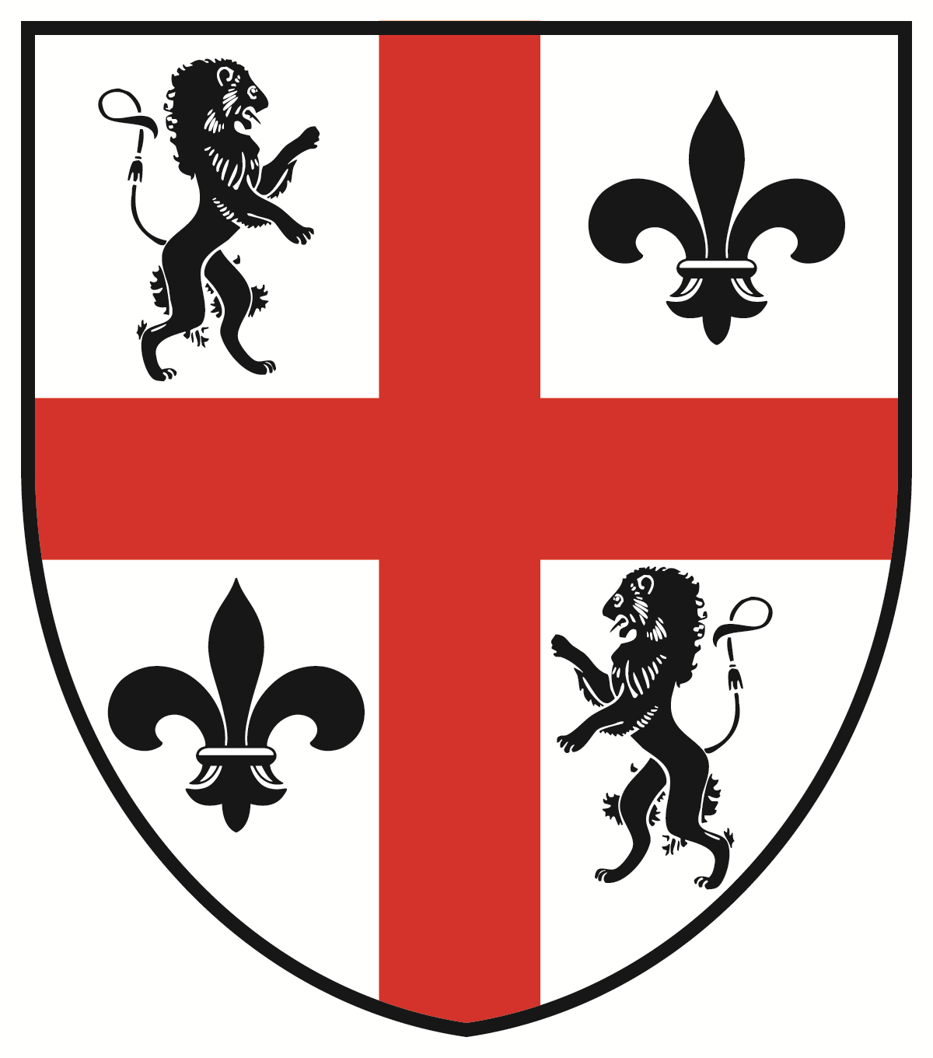

PICTURE: FINGERPRINT: DNA-BLOOD/SALIVA:

Witness:
I hereby solemnly affirm that the information in this patent is true and correct to the best of my knowledge.

_______________________________
Second Witness
Principal claimant:
I hereby solemnly affirm that the information in this patent is true and correct to the best of my knowledge.

_______________________________
Native
Witness:
I hereby solemnly affirm that the information in this patent is true and correct to the best of my knowledge.

_______________________________
First Witness

PATENT OF
NATIVITY

For the nativity of:

John Henry
of the family Doe

Date of nativity:

4th day of April
A.D. 1974

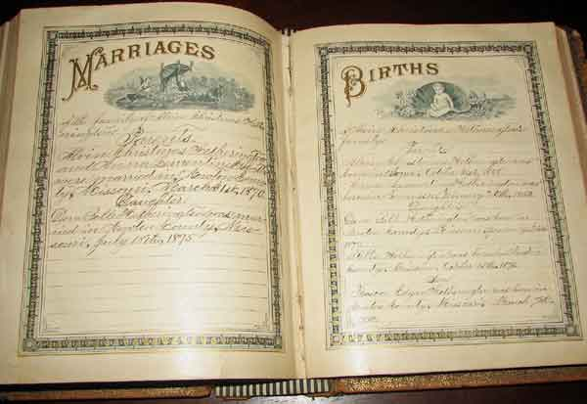
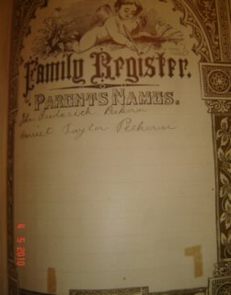
http://www.familyhistoryalive.com/Family-Bibles--Records-of-Family-Members-Births-and-Deaths.html
Bibles With Space for Family Records:
http://www.amazon.com/Family-Bible-Zondervan/product-reviews/0310605830
http://www.amazon.com/NIV-Family-Bible-Hardcover-Zondervan/dp/0310438136/ref=sr_1_2?ie=UTF8&qid=1455568119&sr=8-2&keywords=Family+Bible

