HOW TO ORDER A LONG FORM CERTIFICATE OF LIVE BIRTH

STEP 1: The best and fastest place to order the Long Form BC/COLB is www.VitalChek.com – Do NOT go to the County, do not go anywhere else, please use VitalCheck it is the guaranteed fastest and best source.
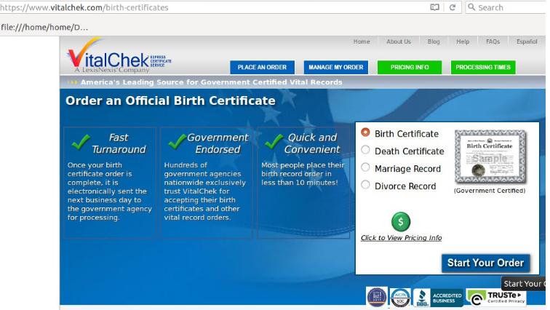

STEP 2: Select “Birth Certificate” > Start Your Order. Follow the Prompts, When Asked “What will you be using the certificate for?” Select “Long Form” if it comes up in the dropdown menu. If “Long Form” doesn’t exist, select “Legal” if it exists. If not, try any of these: “Self”, “Official Govt Purpose” or “ID Purposes” . Follow the rest of the prompts. In about 3-5 days you will have the Long Form in the mail, although it might SAY it takes up to 2 weeks; it won’t.
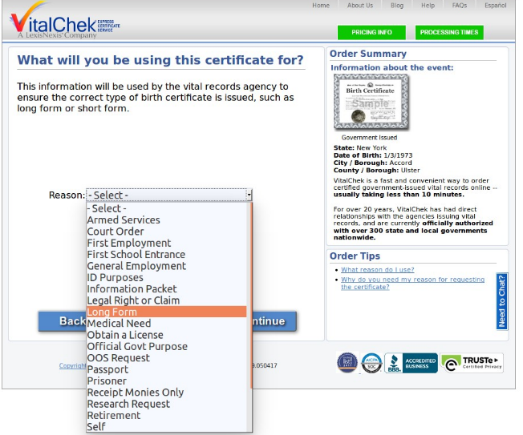

Step 3: Once it arrives in the mail, make sure it says on the top “CERTIFICATE OF LIVE BIRTH”. Unless if the BC document is from Texas, Illinois, Connecticut, city of New York, older State of New York ones, in this case make sure it will instead says “CERTIFICATE OF BIRTH”. If the document says “Record of Birth” this is NOT correct. If the document says “Abstract of Birth” or “Transcript of Birth” then is NOT correct. Next, make sure the State File Number, usually at the top left or top right, is complete and clear and unobstructed.
On the Upper-right hand side of the Birth Certificate, it will say “Birth No” or “State File No.” or something to this effect. Make sure there is a long set of numbers typed or hand-written in.

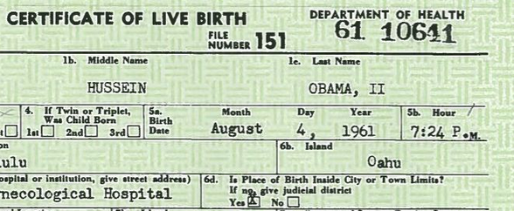

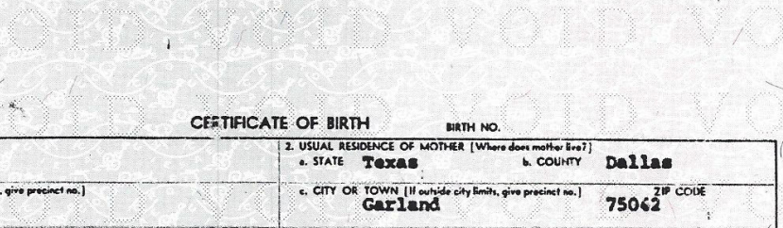
In contrary to:
See How There is Just
A Blank Space instead
Of Listing the Birth
Number and/or State
File Number ?!!?

If there is no number listed, then this is like getting a driver license or passport with no number issued, it is incomplete/invalid. You have a right to demand a fully and official copy with the *Birth Number or State File Number* listed on your BC for no extra cost. You can tell them that this is a unique identifier, to prevent fraud, and it is your right to have one. You can also say the document looks altered, because every other birth certificate has a number there as this is what the State uses to register it. Unless they want to put in writing that your BC has no Birth Number or State File Number (which it does, and which they won’t), for them to redo and issue you a complete one.

